Gedling Borough Council Community Infrastructure Levy (CIL)

Infrastructure Funding Statement 2020/21

Published December 2021

INTRODUCTION

Welcome to the Gedling Borough Council Infrastructure Funding Statement. This statement sets out this year’s income and expenditure relating to the Community Infrastructure Levy (CIL) and Section 106 (s106) Agreements.
As a result of the changes made by the Community Infrastructure Levy (Amendment) (England) (No. 2) Regulations 2019, Local Authorities are required to produce Infrastructure Funding Statements on an annual basis.
Income collected from the CIL and / or s106 (collectively known as ‘planning obligations’ or ‘developer contributions’) is used to help fund the provision of infrastructure which is necessary to support and enable development and growth within the Borough.
Sections 2 and 3 of this statement will provide details of the progress in relation to the collection and expenditure of income generated through the CIL and s106 respectively for the last financial year.
Section 4 sets out the planned future expenditure of income generated through these mechanisms over the next reporting period.

Community Infrastructure Levy & Section 106 Agreements

The Community Infrastructure Levy is a tariff-based charge on the development of new floorspace within the borough. Monies collected through the CIL can be used to fund a wide range of infrastructure (e.g. roads, medical practices and the provision of open space) that is required to meet the future growth needs of the borough.
The Gedling Borough Community Infrastructure Levy (CIL) Charging Schedule was approved by Full Council on 15th July 2015 and came into effect on 16th October 2015. Planning applications decided on or after 16th October 2015 may therefore be subject to CIL.
Section 106 agreements are private agreements, made between local authorities and developers, which can be attached to a planning permission to ensure that a certain development that may otherwise be unacceptable in planning terms, meets the local planning authorities policy requirements. Typical forms of Section 106 Obligations include:

- Site-specific financial contribution;
- Non-financial obligations; and
- Provision of on-site affordable housing.

Summary of Headlines within Statement

Table 1. Key Headlines from the Statement. (to the nearest £)
Summary of CIL Receipts
A total of £561,706 in CIL receipts were collected during the financial year 2020/21.

A total of £1,671,994 receipts were retained at the end of the financial year 2020/21. Of this, £1,666,897 is to be used towards the provision of Strategic Infrastructure within the Borough, whilst £5,097 remains for Infrastructure projects identified through the Neighbourhood portion of the CIL.

A total of £45,305 was passed to Local Parishes during 2020/21 in accordance with Regulations 59A.

A total of £28,085 was allocated to cover the administrative costs of implementing and monitoring the CIL during 2020/21.
Summary of Section 106 Contributions
During the 2020/21 financial year £639,795 was collected in capital contributions through Section 106 Obligations. £43,232 was collected in revenue contributions during the same period.

A total of £98,014 capital and £29,755 revenue contributions have been spent on infrastructure within Gedling Borough Council during the 2020/21 financial year.

At the end of the financial year 2020/21, £2,381,938 of capital contributions and
£163,831 of revenue contributions were retained by Gedling Borough Council.

- COMMUNITY INFRASTRUCTURE LEVY

The amount of CIL payable depends on where the development is located within the borough, the type of use the development comprises of, and the net additional increase in floorspace (£ per Sqm).
Gedling Borough Council’s Charging Schedule currently identifies two different types of Uses which are liable for the CIL. Retail development chargeable by a flat rate across the borough whilst new residential development is split into three different zones. The Charging Schedule and Map of the different zones are available to view from our website at https://www.gedling.gov.uk/cil/.

Alongside the Charging Schedule Gedling Borough Council also adopted a Regulation 123 List in accordance with the regulations in force at the time. Expenditure of the Strategic CIL receipt was approved for the following infrastructure projects:
- The Gedling Access Road (GAR);
- Secondary School Contributions for Gedling Colliery / Chase Farm and Top Wighay Farm strategic sites; and
- The Gedling Country Park Visitors Centre.

Unlike Section 106 Agreements, the CIL payable is a fixed rate which is mandatory and non-negotiable. The charge becomes payable upon the commencement of development.

CIL Income

Table 2 below provides an annual cumulative total of all CIL receipts since Gedling Borough Council first adopted the CIL in 2015. A breakdown of these receipts is provided in greater detail further into the report.

Table 2. Cumulative Total CIL Receipts Retained (to the nearest £)
Year | Income
2015/16 | £0
2016/17 | £36,171
2017/18 | £420,148
2018/19 | £1,038,139
2019/20 | £1,276,677
2020/21 | £1,671,994

Gedling Borough Council adopted the CIL on 16th October 2015. In accordance with the Community Infrastructure Levy (Amendment) (England) (No. 2) Regulations 2019, any planning application which was determined prior to this date is not chargeable. It is for this reason, along with a gap between the granting of permission and implemented, that no receipts were collected during the 2015/16 financial year.

Breakdown of CIL for 2020/21

During the reported year 2020/21, 15 Demand Notices were issued totalling
£1,524,665 in CIL Receipts. To date £968,852 of these receipts have been collected. The remaining sums will be collecting in accordance with the relevant payment plans as approved in the Councils Charging Schedule. The collection of the remaining sums from these Demand Notices will be reported in future Infrastructure Funding Statements in accordance with relevant payment policies.
During the reported year 2020/21 there has been a total of £561,706 collected in CIL receipts from across 14 different developments. A summary of the receipts collected during the year is detailed in Table 3 below.

Table 3. Annual Breakdown of CIL Receipts 2020/21 (1st April 2020 - 31st
March 2021)
Total Receipts Collected | £561,706
Neighbourhood Portion of CIL Receipts | £96,262
Strategic Element of CIL Receipts | £437,359
Administration Element of CIL Receipts | £28,085
Receipts Passed to Local Parishes | £45,305
Receipts Awarded to Non-Parish Neighbourhood  Projects | £93,000.00
CIL Receipts Retained at End of Year | £1,671,994

Of the receipts which were collected during 2020/21, £437,359 is to be spent on strategic infrastructure projects that were identified on the Infrastructure List (previously Regulation 123 List), while £96,262 is to be spent in the locality it was collected as part of the neighbourhood portion of the CIL.
In accordance with Regulation 59A of the Community Infrastructure Levy (Amendment) (England) (No. 2) Regulations 2019, a total of £45,305 worth of CIL Receipts have been passed directly to the Local Parishes from where they were collected.
£28,085 (5%) worth of receipts has been set aside to cover the administration costs of operating the CIL as permitted by the Community Infrastructure Levy (Amendment) (England) (No. 2) Regulations 2019.
During the financial year 20/21, projects which were identified as suitable for funding through the Neighbourhood portion of the CIL, in accordance with Regulation 59F of the Community Infrastructure Levy (Amendment) (England) (No. 2) Regulations 2019, were awarded a total of £93,000.
A total of £1,671,994 in CIL receipts were retained at the end of the financial year 2020/21.

Strategic CIL

Since its adoption of CIL, Gedling Borough Council has now collected £1,666,897 towards the provision of its strategic projects.

Table 4. Annual Strategic CIL Collected (to the nearest £)
Year | Income
2015/16 | £0
2016/17 | £33,695
2017/18 | £333,580
2018/19 | £530,147
2019/20 | £332,116
2020/21 | £437,359
Total | £1,666,897

Following its introduction in 2015, the strategic portion of the CIL collected has been retained for the construction of Gedling Access Road (GAR) which remains the Council’s first priority in terms of key infrastructure within the Borough. The Borough Council has agreed to make a contribution of up to £4.48 million from the Strategic CIL receipt. Payment to the County Council will be made in phases upon the receipt of funds and this will be determined by a transfer agreement.
The GAR is a new 3.8km single carriageway road which will provide a link between the B684 Mapperley Plains and the A612 Trent Valley Road / Nottingham Road. The provision of this piece of infrastructure is vital to support planned growth in this area. Construction of the GAR began in January 2020 and is expected to be completed in Spring 2022. A video showing the proposed layout and route of the Gedling Access Road can be found at https://www.nottinghamshire.gov.uk/transport/roads/gedling- access-road/construction.

Figure 1. Map of Gedling Access Road
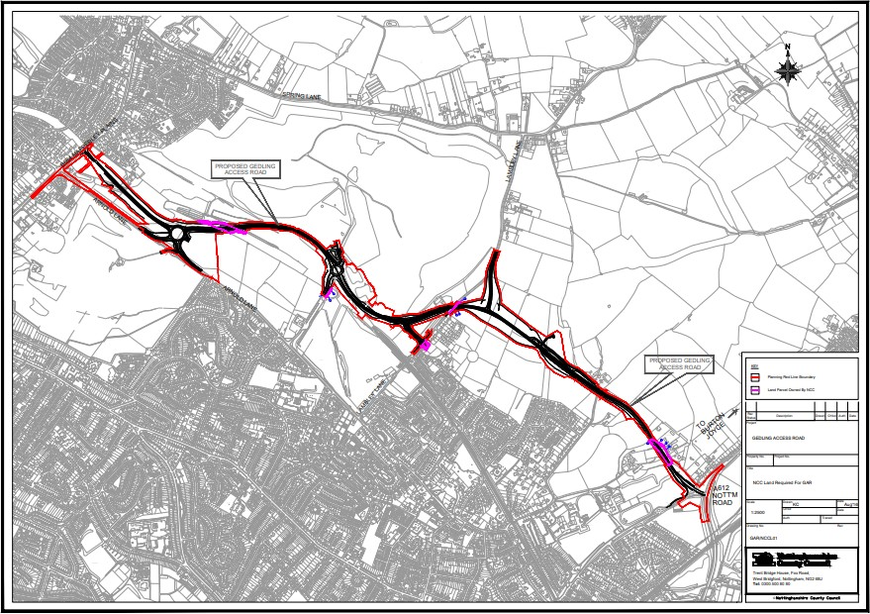

    - Neighbourhood CIL

Under the Community Infrastructure Levy (Amendment) (England) (No. 2) Regulations 2019 a ‘meaningful proportion of CIL receipts are to be passed to local town or parish councils for the area where development takes place. This is known as the ‘neighbourhood portion’. The neighbourhood portion to be passed to the local council is set at 15% of the relevant CIL receipts (up to a cap of £100 per existing council tax dwelling) or 25% with no maximum cap specified where there is a Neighbourhood Development Plan in place. At this time there are four Neighbourhood Plans ‘made’ within Gedling Borough:
      - Burton Joyce Neighbourhood Plan,
      - Calverton Neighbourhood Plan,
      - Linby Neighbourhood Plan, and
      - Papplewick Neighbourhood Plan.

Table 5 below shows the portion of the Neighbourhood CIL Receipts which have been collected on behalf of local parishes.

Table 5. Neighbourhood CIL Awarded to Local Parishes (to the nearest £)
Year | Income
2015/16 | £0
2016/17 | £3,842
2017/18 | £12,374
2018/19 | £8,059
2019/20 | £23,808
2020/21 | £45,305
Total | £93,388

Where there is no Parish Council, Regulation 59A of the Community Infrastructure Levy (Amendment) (England) (No. 2) Regulations 2019 places a duty on charging authorities to allocate at least 15% (up to a cap of £100 per existing council tax dwelling) or 25% (uncapped) where there is a ‘made’ Neighbourhood Plan, of CIL receipts to spend on priorities that should be agreed with the local community in areas where development is taking place. Gedling Borough Council undertake annual consultations with local residents and groups to identify and assess projects which may be suitable for Non-Parish neighbourhood funding. Where no suitable projects are identified the Neighbourhood portion is carried over to the next financial year. Further information regarding the Neighbourhood portion of the CIL can be found on the Gedling Borough Council website at https://www.gedling.gov.uk/cil/.

Gedling Borough has 11 Parishes where the Neighbourhood portion of CIL Receipts will be passed to the Parish Councils if developments take place in those areas. The Parishes cover the following areas:

      - Bestwood Village;
      - Burton Joyce;
      - Calverton;
      - Colwick;
      - Lambley;
      - Linby;
      - Newstead;
      - Papplewick;
      - Ravenshead;
      - St Albans, and
      - Woodborough.

In accordance with the Community Infrastructure Levy (Amendment) (England) (No. 2) Regulations 2019, Parish Councils must publish their own annual reports which detail funding and expenditure for each year where they have received monies passed down through the Neighbourhood Portion through CIL.

Non-Parish Neighbourhood CIL

It should be noted that the extent of the Parishes does not cover the majority of the urban area of Gedling Borough (with the exception of Colwick). This creates a gap in the coverage for the Neighbourhood portion in the Borough. When development takes place in this area Gedling Borough Council will determine, in consultation with its residents, how to expend this element of the CIL in accordance with Regulation 59F of with the Community Infrastructure Levy (Amendment) (England) (No. 2) Regulations 2019.
Below is a table showing the amount of CIL which has been collected and allocated towards the Non-Parish Neighbourhood element during the last financial year.
Table 6. Non-Parish Neighbourhood CIL Collected (to the nearest £)
Year | Income
2015/16 | £0
2016/17 | £2,476
2017/18 | £50,397
2018/19 | £91,344
2019/20 | £46,423
2020/21 | £50,957
Total | £241,597

To date Gedling Borough Council have awarded funding to five pieces of infrastructure through the Non-Parish Neighborhood portion. These include the three projects which were previously detailed within the 2019/20 Infrastructure Funding Statement and two new projects that were award during the last round of nominations.

The two latest projects which were successful in their bids for CIL Neighbourhood funding are details below.

Green Lung Corridor

In 2021 £50,000 was awarded to the creation of new green corridor between Digby Park / Mapperley Golf Course and the Gedling Country Park.
The Green Lung Corridor would result in the redevelopment and enhancement of existing footpaths, improving connectivity between several pieces of green infrastructure across this route.
As part of the project existing Green Space, including an old Tree Trail at Digby Park which has fallen into decline, will be refurbished and new signage, bins, benches and further tree planting will be implemented.
In addition to the above the project will also include surface works to improve drainage in such places along the Green Corridor where the paths suffer from poor drainage, most notably sections of the path adjacent to Kneeton Close.
Works are expected to commence in Winter 2021/22.

Arnold Marketplace

In 2021 a total of £43,000 was awarded towards the construction and improvement of the public realm in association with the new Arnold Marketplace development which was granted Planning Permission on the 27th October 2020.
The project would facilitate the provision of hard and green infrastructure within the locality of the new Arnold Marketplace development to create a more attractive marketplace and public space for local residents.
Works are currently underway on the construction of the new marketplace building and a completion date of spring 2022 is targeted for all works.

To date a total of £236,500 in CIL receipts has been awarded to infrastructure projects in accordance with Regulation 59F of the Community Infrastructure Levy (Amendment) (England) (No. 2) Regulations 2019. At the end of the financial year 2020/21 £5,097 of CIL Receipts remain with Gedling Borough Council for allocation towards the funding of future nominated projects.

Figure 2. Pie Chart showing allocation of Non-Parish Neighbourhood Funding

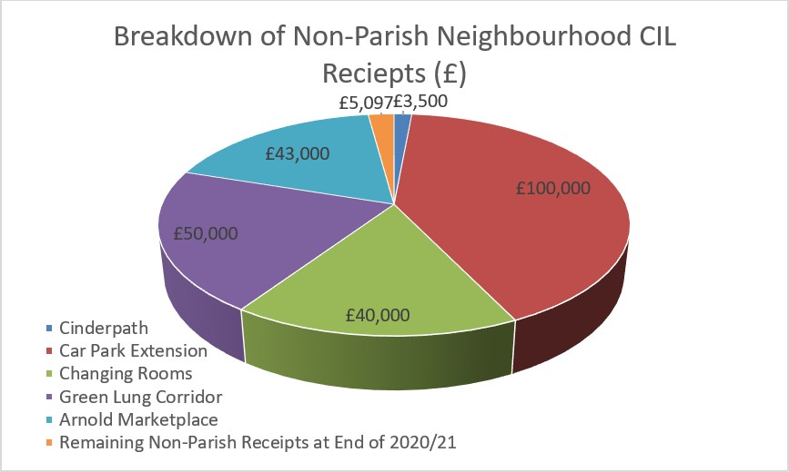

    - CIL Administration Portion

The remaining 5% of monies collected through CIL Receipts is made available for Charging Authorities to cover the administrative costs associated with implementing and enforcing the CIL.
To date a total of £105,362 has been collected towards covering the costs of operating the CIL within Gedling Borough Council. Table 7 below shows a breakdown of the annual receipts collected towards this portion of the CIL.

Table 7. Administration CIL Collected (to the nearest £)
Year | Income
2015/16 | £0
2016/17 | £2,106
2017/18 | £20,861
2018/19 | £33,134
2019/20 | £21,176
2020/21 | £28,085
Total | £105,362

SECTION 106 OBLIGATIONS

Gedling Borough Councils approach to planning obligations is set out within the Aligned Core Strategy 2014 (Part 1 Local Plan), the Local Planning Document 2018 (Part 2 Local Plan) and Gedling Borough Councils Planning Obligations Protocol 2014. Priorities which should be considered when negotiating planning applications include factors such as Affordable Housing, Open Space, Education and Primary Healthcare.
More detailed guidance regarding how obligations are calculated can be found in Gedling Borough Councils Supplementary Planning Documents and Guidance on the Gedling Borough Councils website at https://www.gedling.gov.uk/resident/planningandbuildingcontrol/planningpolicy/adopt edlocalplanandpolicydocuments/.

New Section 106 Agreements Signed

During the financial year 20/21 there have been several new planning permissions granted for larger developments which were subject to Section 106 Agreements. Table 8 below provides a list of these developments.

Table 8. List of New Section 106 Agreements 20/21
App Ref | Location | Breakdown of Obligations
2018/1034 | Land at Orchard Close, Burton Joyce, Nottinghamshire | Local Employment and Skills Plan.  Open Space Contribution £49,330.40 (Index Linked).  Affordable Housing provision on-site.
2019/0213 | Land to the West of Mapperley Plains, Mapperley | Monitoring Fee.  Local Employment and Skills Plan.  Open Spaces Scheme to be submitted and approved by the Borough Council.  Primary Healthcare Contribution £88,868.00 (Index Linked).  Affordable Housing provision on-site.
2017/1263 | Land Adj Dark Lane, Calverton,  Nottinghamshire | Monitoring Fee.  Local Employment and Skills Plan.  Open Space Contribution £106,668.36 (Index Linked).  Primary Healthcare Contribution £35,595 (Index Linked).  Affordable Housing provision on-site.
2019/1186 | Land at the end of Linden Grove, | Monitoring Fee.  Local Employment and Skills Plan.

 | Gedling, Nottingham | Open Spaces Scheme to be submitted and approved by the Borough Council.  Primary Healthcare Contribution £65,025.00 (Index Linked).  Affordable Housing provision on-site.

A copy of each Section 106 Agreement and other public documents relevant to each Planning Application can be viewed electronically on the planning portal at https://pawam.gedling.gov.uk/online-applications/.

Section 106 Capital Contributions Overview

A total of £683,027 was received in Section 106 Contributions during the financial year 2020/21,
Table 9 provides a breakdown of the total contributions received from S106 Contributions and the amount of Expenditure over the last financial year.

Table 9. Overview of S106 Contributions 2020/21 (to the nearest £)
Contributions Received |  | Expenditure
Capital | Revenue | Capital | Revenue
£639,795 | £43,232 | £98,014 | £29,755

During the last financial year Gedling Borough Council have collected more financial contributions from Section 106 Agreements than the previous three years combined (2017-2020 resulted in a total of £634,813.49 S106 contributions collected). This mechanism demonstrates Gedling Borough Councils continued commitment to ensure that, when necessary, the impacts of developments within the Borough are appropriately mitigated.

Figure 3. Annual S106 Income and Expenditure since 2017/18

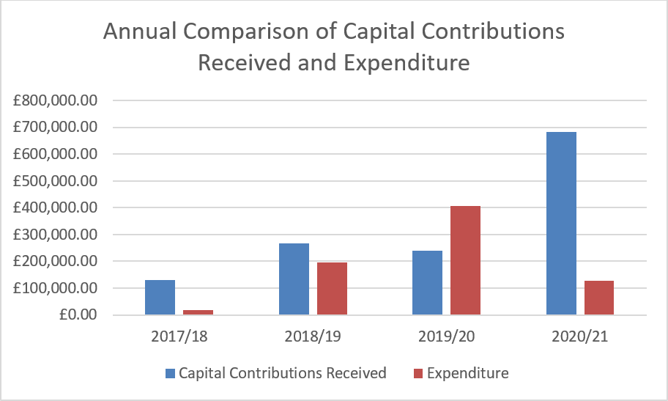

  - Capital Contributions retained at end of Financial Year 20/21

Contributions collected through a Section 106 agreement usually have a clause stating the timeframe in which the contribution is to be expended. Currently there are no S106 contributions which have exceeded the timeframe and plans are in place to ensure that the contributions are expended prior to the repayment dates set.

In the majority of S106 agreements the payback period is usually 10 years however these clauses can range between 5 – 10 years.

Table 10 below details the Capital Contributions which have been retained at the end of the financial year 2020/21. These monies have yet to be allocated to a specific scheme or project.

Table 10. Capital Contributions held at 31st March 2021 (to the nearest £)
Site | Application Reference | S106  Received | Contributions Held | Provision | Deadline to for expenditure
Spring Lane | 2007/0748 | 2014 | £24,924 | Affordable Housing | 2024
 |  |  | £25,688 | Open  Space
Land at Wighay Road | 2014/0950 | 2016 | £94,822 | Open Space | 2026
 |  |  | £560,567 | Affordable Housing
 |  |  | £21,741 | Healthcare
Land at Stockings Farm | 2010/0437 | 2016 | £435,232 | Healthcare | 2026
Bradstone Drive, off Spring Lane | 2014/0740 | 2017 | £23,903 | Healthcare | 2027
Land North of Papplewick Lane, Linby | 2013/1406 | 2017 | £37,346 | Healthcare | 2027
Land Off Cavendish Road | 2014/0559 | 2017 | £35,243 | Open Space | 2027
Land North of Papplewick  Lane, Linby | 2013/1406 | 2018 | £215,568 | Affordable Housing | 2028
Land South of Woodchurch  Road | 2018/0911 | 2018 | £28,518 | Open Space | 2028
Land at Teal Close,  Netherfield | 2013/0546 | 2019 | £111,237 | Healthcare | 2029
Land West of Westhouse  Farm | 2014/0238 | 2019 | £27,818 | Healthcare | 2029

Land Between Main St and  Hollinwood | 2012/0941 | 2019 | £99,536 | Open Space | 2029
Land North of Papplewick Lane | 2013/1406 | 2020 | £454,104 | Affordable Housing | 2030
 |  |  | £81,739 | Healthcare | 2030
Land west of Beeston Close,  Bestwood | 2017/0194 | 2020 | £36,826 | Open Space | 2030
Bradstone  Drive, off Spring Lane | 2014/0740 | 2020 | £22,692 | Healthcare | 2030
Land to the West of Mapperley  Plain | 2019/0213 | 2020 | £44,434 | Healthcare | 2030
Total |  |  | £2,381,938

Figure 4 below provides a breakdown of all the contributions currently held by Gedling Borough Council per service provision.

Figure 4. Pie Chart showing S106 Contributions held per type of provision
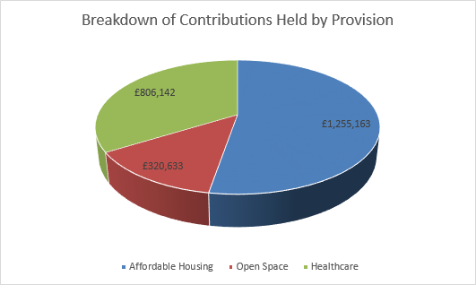

  - Section 106 Capital and Revenue Expenditure

In 2020/21 Section 106 Contributions totalling £98,014 were spent on infrastructure projects across the borough. Table 11 indicates which developments the contributions were drawn down from and what projects they were allocated to.

Table 11. Capital Contributions expended during 2020/21 (to the nearest £)
Site | Application Reference | S106  Contribution Received | Amount Spent | Provision/Project Funded
Spring Lane, Mapperley | 2007/0748 | 2014 | £97,814 | Gedling Country Park Seating Area.
Spring Lane, Mapperley | 2007/0748 | 2014 | £200 | Burton Road Affordable Housing Project
Total |  |  | £98,014

As well as the collection and expenditure of capital contributions, it is not uncommon for Section 106 Agreements to require the payment of revenue contributions towards the ongoing maintenance of infrastructure which is provided. These payments are typically agreed for a period of 10 years. The majority of revenue contributions which are collected by Gedling Borough Council relate primarily to ongoing maintenance works on Open Spaces sites that the Council have adopted. Table 12 below sets out revenue contributions which have been collected by the Local Authority and the developments they have been spent on thus far.

Table 12. Revenue Contributions Received (to the nearest £)
Site | Date Received | Balance at 1st April 2020 | Annual Payment  2020/21 | Remaining Balance at 31st March 2021
Spring  Lane | 2016 | £2,844 | £569 | £2,275
Park Road,  Bestwood | 2017 | £17,880 | £0 | £17,880
Edison Way,  Arnold | 2007 | £10,425 | £5,213 | £5,212
Downham Close,  Arnold | 2018 | £4,126 | £825 | £3,301
Brooklands  Drive | 2008 | £2,864 | £1,446 | £1,418
Arnold View Primary  School | 2009 | £14,847 | £2,474 | £12,373
Burton Road,  Gedling | 2009 | £3,819 | £763 | £3,056
188-194  Mapperley Plains | 2012 | £11,421 | £1,904 | £9,517
333-339  Mapperley Plains | 2015 | £14,453 | £2,409 | £12,044
Spring  Lane | 2017 | £77,403 | £11,058 | £66,345
Land at Teal Close,  Netherfield | 2018 | £2,550 | £0.00 | £2,550
Howbeck  Road | 2016 | £30,956 | £3,096 | £27,860
Total |  | £193,588 | £29,757 | £163,831

Section 106 Monitoring Fees

The Community Infrastructure Levy (Amendment) (England) (No. 2) Regulations 2019 introduced a provision for Local Authorities to insert Monitoring Clauses into future Section 106 Agreements. These clauses allow fees to be levied to support the costs of monitoring and reporting on the delivery of Section 106 planning obligations.
Whilst the amendments to the Regulations allows for monitoring fees to be levied, any such fee must be both fair and reasonable based on the Local Authorities estimates of the actual costs of monitoring the agreement. The Borough Council has an adopted policy which can be viewed on the council’s website at the following link - https://democracy.gedling.gov.uk/documents/s16689/Appendix%201%20Monitoring
%20Fee%20Ststement.pdf.

To date Gedling Borough Council have sought Monitoring Fees in relation to eleven developments. A list of these developments and the relevant monitoring fees are detailed below. Developments where the monitoring fees which were received and reported in last year’s Infrastructure Funding Statement have been removed from the table below.

Table 13. Section 106 Agreements with Monitoring Fees (to the nearest £)
Site | Date S106 Signed | Value of Monitoring  Fee | Status
Carlton Police Station, Cavendish Road, Carlton,  Nottingham, NG4 3DZ | 29.03.2019 | £315 | Received
Land North West, Park Road,  Calverton, Nottinghamshire | 18.02.2020 | £2,520 | Received
Land On Flatts Lane,  Calverton, Nottinghamshire | 03.03.2020 | £2,835 | Payment Due
Land at Orchard Close, Burton  Joyce, Nottinghamshire | 26.03.2020 | £2,520 | Not  Commenced
Land at Brookfields Garden Centre, Mapperley Plains,  Nottingham, NG3 5RW | 26.03.2020 | £2,205 | Not Commenced
84-86 Chapel Lane,  Ravenshead, Nottingham | 03.07.2020 | £1,260 | Received

Land at Chase Farm,  Mapperley Plains, Mapperley, Nottingham | 09.07.2020 | £1,890 | Not Commenced
Land Adj Dark Lane, Calverton,  Nottinghamshire | 12.11.2020 | £2,231 | Received
Land at the end of Linden  Grove, Gedling, Nottingham | 28.01.2021 | £2,520 | Not  Commenced
Total |  | £18,296

Non-Monetary Contributions

In some instances, financial contributions may not be deemed necessary to mitigate against the impacts of a development. Instead it may be considered that the provision of on-site infrastructure such as Affordable Housing or, the agreement of future plans such as local employment schemes may be sufficient.
Table 14 details developments approved during the reporting year which include a provision to provide Affordable Housing on site.

Table 14. Provision of Affordable Housing 2020/21
Site Address | Application  Reference | Date S106  Signed | Affordable Housing  Obligation
Land at Orchard Close, Burton Joyce, Nottinghamshire | 2018/1034 | 26.03.2020 | 4 dwellings to be Affordable Housing Units (3 Affordable Rented Units and 1 Intermediate  Housing)
Land to the West of Mapperley Plains, Mapperley | 2019/0213 | 08.10.2020 | 49 dwellings to be Affordable Housing Units (16 Shared Ownership, 33  Affordable Rented)
Land Adj Dark Lane, Calverton,  Nottinghamshire | 2017/1263 | 12.11.2020 | 11 dwellings to be Affordable Housing Units (8 Affordable Rented Units and 3 Intermediate  Housing)
Land at the end of Linden Grove, Gedling, Nottingham | 2019/1186 | 29.01.2021 | 24 dwellings to be Affordable Housing Units (17 Affordable Rented Units and 7% Shared  Ownership)

Each of the Planning Permissions, which were subject to a Section 106 Agreement, granted during the 2020/21 financial year include a requirement to submit an Employment and Skill Plans. This further demonstrates Gedling Borough Councils on- going dedication to working with partners and local business to provide greater opportunities where possible. Table 15 details the developments which require such obligations.

Table 15. Employment and Skills Plans Agreed 2020/21
Site | Date S106 Signed
Land at Orchard Close, Burton Joyce,  Nottinghamshire | 26.03.2020
Land to the West of Mapperley Plains,  Mapperley | 08.10.2020
Land Adj Dark Lane, Calverton, Nottinghamshire | 12.11.2020
Land at the end of Linden Grove, Gedling,  Nottingham | 28.01.2021

Monies Borrowed

No Section 106 monies were spent repaying money borrowed during the financial year 2020/21.

GOING FORWARD – PLANNED EXPENDITURE

In accordance with the latest amendments to the CIL Regulations, the IFS outlines the future priorities in terms of expenditure over the next reporting period (2021/22).
The amount of CIL receipts generated in any given financial year is dependent upon the implementation of planning permissions and phasing of developments. Whilst it is possible to calculate the amount of CIL receipts expected through the totalling of Liability Notices generated, this will only ever be a theoretical figure as payment only becomes due upon the commencement of development.
Contributions generated through Section 106 Agreements must be spent in accordance with the terms set out within each Agreement (as negotiated during the planning application process). These terms will often have several trigger points, such as number of residential units occupied, which will cause the payment to become due.

In this way, funding obtained through Section 106 agreements are heavily reliant upon the phasing and delivery of development and can vary greatly on a site by site basis, making it difficult to accurately forecast future income.

Strategic CIL

Since Gedling Borough Council first adopted the CIL in 2015 the Strategic portion of CIL Receipts have been ring-fenced for the provision of the Gedling Access Road (GAR). The GAR remains a vital piece of infrastructure to support growth in the area and provide greater connectivity between the central urbanised area of the Borough such as Mapperley and Arnold, and more rural settlements such as Burton Joyce and Stoke Bardolph. Until such a time as the funding gap for the GAR has been reached, CIL receipts for the Strategic element will continue to be ring-fenced for this piece of infrastructure.
Gedling Borough Council have committed to allocate a total of £4.48 million towards the Gedling Access Road. In total approx. £1.67 million has been collected so far through the Strategic portion of the CIL, as such there remains an outstanding sum of
£2.81 million which will continue to be collected as more CIL receipts are paid.

Once the funding gap for the GAR has been reached the focus will shift towards secondary school contributions at Gedling Colliery / Chase Farm and Top Wighay Farm strategic sites. It is envisaged that the interim funding gap for Secondary School facilities required for these two developments can be reduced through education contributions delivered through Section 106 Agreements. Expenditure on a possible visitor centre at Gedling Country Park has also been approved. No decision have been taken with regards to the prioritisation of these projects.

Neighbourhood Portion CIL

The Neighbourhood CIL will continue to be spent on providing and improving existing infrastructure within the Borough. 15% of CIL receipts will continue to be allocated to the Neighbourhood portion of the CIL rising to 25% in places where a Neighbourhood Plan has been adopted.
The Neighbourhood portion of CIL receipts collected in local parishes will continue to transferred directly to these governing bodies for allocation.

Throughout the year, local community groups and stakeholders will be able to nominate projects for the Neighbourhood portion of the CIL receipts which are collected within non-parish areas. Submissions can be made by completing the electronic form on the Gedling Borough Council website at the following link - https://apps.gedling.gov.uk/forms/default.aspx?formid=86.

At the beginning of September an annual review of all the projects nominated will commence and shortly after a Local Infrastructure Schedule (LIS) will be published along with a comprehensive project assessment. Following the publication of the LIS and project assessment a public consultation will be undertaken and a final report identifying which if any projects have been successful. If no projects are nominated or deemed appropriate the Neighbourhood CIL will be carried over to the next financial year.
Examples of types of Infrastructure which may be appropriate include:

- Improvements to local open spaces;

- Street improvements;

- Drainage improvements;

- Town centre regeneration and

- Recreational facilities.

It is important that any project which is nominated is able to demonstrate how it fulfils a need created by new development within the area and, should wherever possible, show availability to provide match funding through other revenue streams.

Section 106 Contributions

The Gedling 2020/21 capital programme sets out the future spending priorities of Gedling Borough Council. Currently two infrastructure projects totalling £93,000 have been identified in the next financial year. The projects which have been identified so far as suitable for Section 106 funding are detailed in table 16 below.

Table 16. Section 106 Contributions 2021/22 Allocations
Open Spaces
Sand Martin Bank & Bird Hide at Gedling Country Park £18,000 from Spring Lane
2007/0748 contributions.
Lambley Lane Changing Rooms & Pitch Renovation £75,000.
Affordable Housing
No funding committed for 21/22 to date.
Healthcare
No funding committed for 21/22 to date.
Education
Education Contributions are requested and secured by Nottinghamshire County Council. The County Council are required to draft their own Infrastructure Funding Statement reporting on financial contributions received through S106 Agreements. A copy of this document will be available for viewing on Nottinghamshire County
Councils website.

Careful consideration will be given to remaining Section 106 Contributions which are being held by Gedling Borough Council. These remaining sums will be monitored and projects identified in accordance with the relevant legal S106 Agreements.

Infrastructure List

Table 17. The Infrastructure List
Community Infrastructure Levy
Construction of Gedling Access Road to facilitate Gedling Colliery / Chase Farm development. | To be funded through  Strategic portion of CIL Receipts collected.
Secondary School Contributions at Gedling Colliery / Chase Farm and Top Wighay Farm  developments. | To be funded through Strategic portion of CIL  Receipts collected.
Gedling Colliery Country Park Visitors Centre | To be funded through  Strategic portion of CIL Receipts collected.
Annual assessment of suitable Infrastructure projects identified in accordance with Regulation 59F of the Community Infrastructure Levy  (Amendment) (England) (No. 2) Regulations 2019. | To be funded through the Neighbourhood portion of CIL Receipts collected.
Section 106 Contributions
Provision of Affordable Housing Units either on-site  of through capital contributions. | To be secured through  Section 106 Obligations.
Provision of Open Spaces including new  infrastructure and improvements to existing sites. | To be secured through  Section 106 Obligations.
Provision for Primary Healthcare including new infrastructure and improvements of existing  surgeries. | To be secured through Section 106 Obligations.
Any other future infrastructure which is deemed necessary, in accordance with the Community Infrastructure Levy (Amendment) (England) (No. 2)  Regulations 2019 | To be secured through Section 106 Obligations.

The above is not a final account of all infrastructure that may be funded through Planning Obligations. The Infrastructure List will be monitored and may be updated accordingly to represent new projects that are identified in the future.

If you have any further queries or comments about this statement, please do not hesitate to contact us via email at CIL@gedling.gov.uk or phone on 0115 901 3731.

